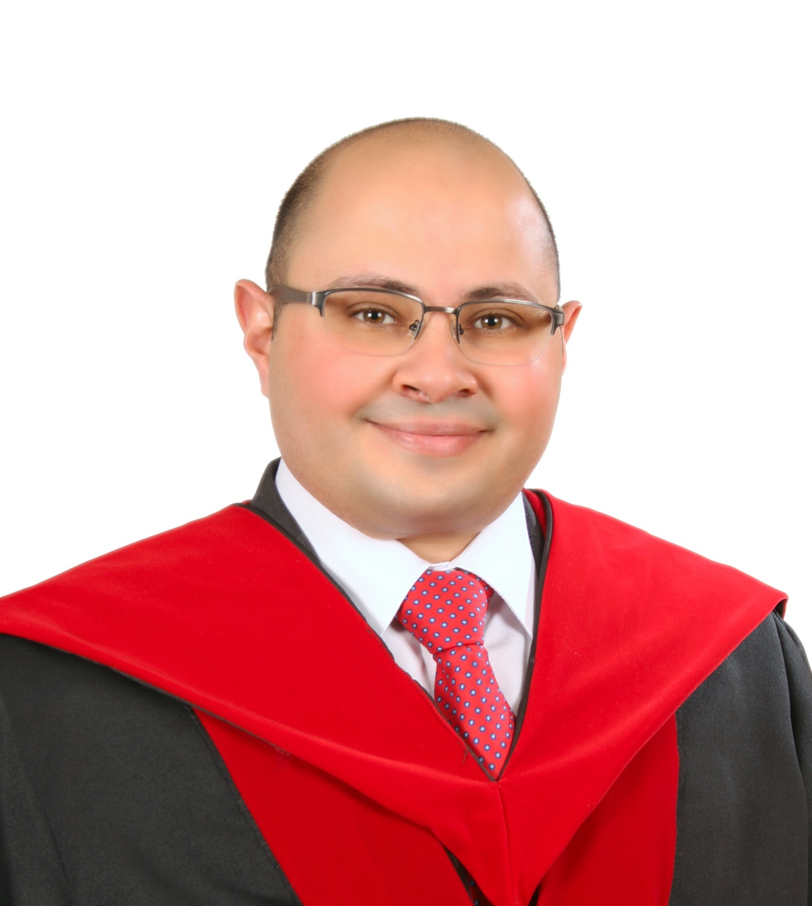
Yazeed S. Jweihan
Assistant Professor of Civil Engineering

Details    +962 798 755 500  Y.Jweihan@mutah.edu.jo  Y.Jweihan@gmail.com  Date of birth  21/06/1989  Nationality  Jordanian  Marital Status  Married  Links  SCOPUS  Google Scholar  ORCiD  ResearchGate  LinkedIn  Skills  AutoCAD  SketchUP  MATLAB  Python  PRIMAVERA  SPSS | Profile  Dr. Yazeed Suleiman Jweihan is an Assistant Professor of Civil Engineering with research experience and academic teaching in the Civil and Environmental Engineering (CEE) Department at Mutah University, Jordan, since December 2019. Dr. Jweihan has M.Sc. and Ph.D. degrees in Civil Engineering from The University of Texas at Arlington, USA, with an excellent GPA of 4.0/4.0 in 2017 and 2019, respectively. He earned his B.Sc. degree in Civil Engineering from Mutah University in 2011. His research interests include pavement and asphalt mix materials, cementitious materials, concrete properties, sustainability in construction, and applications of machine learning in civil engineering.  Education  PhD in Civil Engineering, The University of Texas at Arlington, USA  January 2018 — December 2019  MSc. in Civil Engineering, The University of Texas at Arlington, USA  January 2016 — December 2017  BEng in Civil Engineering, Mutah University, Jordan  September 2007 — August 2011  Employment History  Assistant Professor in Civil Engineering at College of Engineering, Mutah University, Jordan  December 2019 — Present  Head of the Civil and Environmental Engineering Department at College of Engineering, Mutah University, Jordan  October 2023 — Present  Assistant Dean of Quality Assurance and E-Learning at College of Engineering, Mutah University, Jordan  October 2021— October 2023  Teaching Assistant at the Civil Engineering Department, The University of Texas at Arlington, USA  August 2016 — August 2017  August 2018 — August 2019  Quality Control and Construction Engineer at Al-Own Advanced for Contracting Company, Jordan  November 2011 — December 2014  - Disi-Mudawarra to Amman water conveyance system Project.  Trainee Civil Engineer at the Ministry of Public Works and Housing, Jordan  June 2011 — August 2011  - Government building directorate, Al-Karak  Institutional services-Mutah University  Member in the College of Engineering Council.  Member in the ABET Accreditation Preparatory Committee of the College of Engineering.  Member in the Curriculum Committee of the CEE Dep.  Head of the E-learning Committee of the College of Engineering.  Member in the Tendering Committee of the College of Engineering.  Member in the Quality Assurance Committee of the CEE Dep.  Member in the Course Equivalences Committee of the CEE Dep.  Member in the Postgraduate Studies Committee of the CEE Dep.  Member in the CEE Department Labs Development Committee.  Funded Projects  Establishing the Materials and Energy Laboratory (MSEL) at Mutah University  June 2021 — June 2024  - Funder: Mutah University-Deanship of Scientific Research.  - Project value: $250,000  Teaching Profile  - Pavement Design  - Highway Engineering  - Highway Engineering Laboratory  - Surveying for Engineers  - Retaining Earth Structures  - Foundation Engineering  - Numerical Methods  - Engineering Drawing  - Construction Materials and Concrete Properties  - Laboratory of Construction Materials and Concrete Properties  HONORs  - Government Scholarship to complete Master's and PhD studies (2016-2020).  - Mutah University President’s List/ University Shield for Excellence (2009).  - Mutah University Dean’s List for excellent students (Four times, 2007-2009)  Training Courses  - Modern Learning Patterns and Electronic Content Development- Academic Development & Quality Assurance Center, Mutah University (2023).  - Study Course Design, Modern Teaching and Learning Methods, Managing and Organizing a University Class, Ethics of University Education, Students Evaluation Strategies, and Course File Preparation - Academic Development & Quality Assurance Center, Mutah University (2022).  - “How to Qualify for ABET Accreditation Including Virtual Visit Training”- Association of Arab Universities, Jordan (2021).  - ITA (UTA’s Developmental English Course of International Teaching Assistants)- The University of Texas at Arlington, USA (2017).  - GESP (Graduated English Skills Program)- The University of Texas at Arlington, USA (2016).  - MUCDL (Mutah University Computer Driving License)- Academic Development & Quality Assurance Center, Mutah University (2014).  - Confined Space, Construction hazards, Pipeline Construction Management, and “A-Z” Safety Courses - GAMA Energy Co., Jordan (2012-2013).  - Primavera P6, Design of Concrete Structures, Project Management, Quantity Surveying, and AutoCAD Courses – Jordan Engineers Association (2010-2013).  - Computer Skills: MATLAB, SPSS statistical software, Mathcad, Python, AutoCAD, SketchUp, Microsoft Office.  Published Research  Journal Articles  - Abarkan, I., Rabi, M., Ferreira, F.P.V., Shamass, R., Limbachiya, V., Jweihan, Y.S. and Santos, L.F.P., 2024. Machine learning for optimal design of circular hollow section stainless steel stub columns: A comparative analysis with Eurocode 3 predictions. Engineering Applications of Artificial Intelligence, 132, p.107952.  https://www.sciencedirect.com/science/article/pii/S0952197624001106  - Jweihan, Y.S., 2024. Implementation of ceramic waste as fine aggregate in rigid pavement: performance enhancement through silane coupling agent. Arabian Journal for Science and Engineering, 49(4), pp.4557-4565.  https://link.springer.com/article/10.1007/s13369-023-08165-1  - Rabi, M., Jweihan, Y.S., Abarkan, I., Ferreira, F.P.V., Shamass, R., Limbachiya, V., Tsavdaridis, K.D. and Santos, L.F.P., 2024. Machine learning-driven web-post buckling resistance prediction for high-strength steel beams with elliptically-based web openings. Results in Engineering, p.101749.  https://www.sciencedirect.com/science/article/pii/S2590123024000021  - Momani, Y., Alawadi, R., Jweihan, Y.S., Tarawneh, A.N., Al-Kheetan, M.J. and Aldiabat, A., 2024. Machine learning-based evaluation of punching shear resistance for steel/FRP-RC slabs. Ain Shams Engineering Journal, p.102668.  https://www.sciencedirect.com/science/article/pii/S2090447924000431  - Al-Kheetan, M.J., Jweihan, Y.S., Rabi, M. and Ghaffar, S.H., 2024. Durability Enhancement of Concrete with Recycled Concrete Aggregate: The Role of Nano-ZnO. Buildings, 14(2), p.353.  https://www.mdpi.com/2075-5309/14/2/353  - Al-Jrajreh, S.S., Al-Hamaiedeh, H., Al-Kheetan, M.J., Jweihan, Y.S. and Aljaafreh, T., 2023. Improvement of ornamental stone wastes as sand replacement in concrete using silane coupling agent. Results in Engineering, 20, p.101580.  https://www.sciencedirect.com/science/article/pii/S2590123023007077  - Al Swalqah, R.A.A., Al-Kheetan, M.J., Jweihan, Y.S. and Al-Hamaiedeh, H., 2023. Synergistic Effect of Treated Polypropylene-Based Disposable Face Masks on Durability and Mechanical Properties of Concrete. Arabian Journal for Science and Engineering, pp.1-9.  https://link.springer.com/article/10.1007/s13369-023-08509-x  - Jweihan, Y.S., Al-Kheetan, M.J. and Rabi, M., 2023. Empirical Model for the Retained Stability Index of Asphalt Mixtures Using Hybrid Machine Learning Approach. Applied System Innovation, 6(5), p.93.  https://www.mdpi.com/2571-5577/6/5/93  - Bayaidah, R.H., Habashneh, A.O., Al-Ma'aitah, S.H., Alfahajin, M.S., Al-Kheetan, M.J., Jweihan, Y.S., Alrwashdeh, S.S., Al-Hamaiedeh, H., and Ghaffar, S.H. (2023). Utilisation of raw oil shale as fine aggregate to replace natural sand in concrete: Microstructure, surface chemistry and macro properties. Results in Engineering, 19, p. 101265.  https://www.sciencedirect.com/science/article/pii/S2590123023003924  - Jweihan, Y. S. (2023). Predictive model of asphalt mixes’ theoretical maximum specific gravity using gene expression programming. Results in Engineering, 101242.  https://www.sciencedirect.com/science/article/pii/S2590123023003699  - Jweihan, Y.S., Romanoschi, S.A., Al-Kheetan, M.J., Tarawneh, A., Momani, Y., Alrwashdeh, S.S. and Grujicic, M.J., 2023. Improvements to the duplicate shear test (DST) device for measuring the fundamental shear properties of asphalt concrete mixes. International Journal of Pavement Research and Technology, 16(5), pp.1255-1266.  https://link.springer.com/article/10.1007/s42947-022-00194-7  - Jweihan, Y. S. (2023). Performance of aged asphalt mixes containing waste oil shale filler. International Journal of Pavement Research and Technology, 1-15. https://link.springer.com/article/10.1007/s42947-023-00311-0  - Almomani, Y., Tarawneh, A., Alawadi, R., Taqieddin, Z. N., Jweihan, Y. S., & Saleh, E. (2023). Predictive models of behavior and capacity of frp reinforced concrete columns. Journal of Applied Engineering Science, 21(1), 143-156. https://www.aseestant.ceon.rs/index.php/jaes/article/view/39723  - Al-Awabdeh, F. W., Al-Kheetan, M. J., Jweihan, Y. S., Al-Hamaiedeh, H., & Ghaffar, S. H. (2022). Comprehensive investigation of recycled waste glass in concrete using silane treatment for performance improvement. Results in Engineering, 16, 100790.  https://www.sciencedirect.com/science/article/pii/S2590123022004601  - Alrwashdeh, S. S., Ammari, H., Jweihan, Y. S., Abu Qadourah, J., Al-Kheetan, M. J., & Al-Falahat, A. A. M. (2022). Refurbishment of Existing Building toward a Surplus Energy Building in Jordan. The Open Construction & Building Technology Journal, 16(1).  https://openconstructionbuildingtechnologyjournal.com/VOLUME/16/ELOCATOR/e187483682208150/FULLTEXT/  - Momani, Y., Alawadi, R., Majdalaweyh, S., Tarawneh, A., & Jweihan, Y. S. (2022). Data-driven machine learning prediction models for the tensile capacity of anchors in thin concrete. Innovative Infrastructure Solutions, 7(5), 294. https://link.springer.com/article/10.1007/s41062-022-00876-y  - Jweihan, Y. S., Alawadi, R. J., Momani, Y. S., & Tarawneh, A. N. (2022). Prediction of Marshall Test Results for Dense Glasphalt Mixtures Using Artificial Neural Networks. Frontiers in Built Environment, 8, 949167.  https://www.frontiersin.org/articles/10.3389/fbuil.2022.949167/full  - Jweihan, Y. S., Romanoschi, S. A., Grujicic, M. J., Talebsafa, M., Popescu, C., Coca, A. M., & Al-Kheetan, M. J. (2022). Development of shear tester with normal stress (STNS) for asphalt concrete mixes. International Journal of Pavement Research and Technology, 1-13.  https://link.springer.com/article/10.1007/s42947-021-00074-6  - Al‐Kheetan, M. J., Al‐Tarawneh, M. A., Ghaffar, S. H., Chougan, M., Jweihan, Y. S., & Rahman, M. M. (2021). Resistance of hydrophobic concrete with different moisture contents to advanced freeze–thaw cycles. Structural Concrete, 22, E1050-E1061.  https://onlinelibrary.wiley.com/doi/abs/10.1002/suco.202000214  - Al-Kheetan, M. J., Rahman, M. M., Ghaffar, S. H., & Jweihan, Y. S. (2020). Comprehensive investigation of the long-term performance of internally integrated concrete pavement with sodium acetate. Results in Engineering, 6, 100110.  https://www.sciencedirect.com/science/article/pii/S2590123020300165  Conference  - Talebsafa, M., Romanoschi, S.A. and Jweihan, Y.S., 2024. Optimization of Continuously Reinforced Concrete Pavement to Truck Platoon Loading (No. TRBAM-24-01426).  https://trid.trb.org/View/2335317  - MSc. Thesis & Ph.D. Dissertation  - Jweihan, Y. S. (2019). Enhancements of Shear Tests for Asphalt Concrete. The University of Texas at Arlington.  https://rc.library.uta.edu/uta-ir/handle/10106/28842  - Jweihan, Y. S. (2018). Improvements to the duplicate shear tester. The University of Texas at Arlington.  https://rc.library.uta.edu/uta-ir/handle/10106/27176  References  Prof. Stefan Ramonoschi, PE., Civil Engineering Department, The University of Texas at Arlington, USA.  romanoschi@uta.edu +1 972 953 5460  John Mladjan Grujicic, Ph.D., PE., Senior Project Manager at GCW, Inc. Las Vegas, Nevada 89146, USA.  JGrujicic@gcwengineering.com +1 702 630 3957  Mohsen Talebsafa, Ph.D., PE., Senior Pavement Engineer at Site Technologies, Texas, USA  mohsen@sitetechnologies.io  Dr. Mamoon Hammad, Senior Program Manager at Jacobs Engineering, Fort Worth, Texas 76137, USA  mamoon.hammad@outlook.com +1 571 331 9247

