CURRICULUM VITAE

Rami M. Al Majali MBBS, MRCPCH, MA, CPE

Personal :
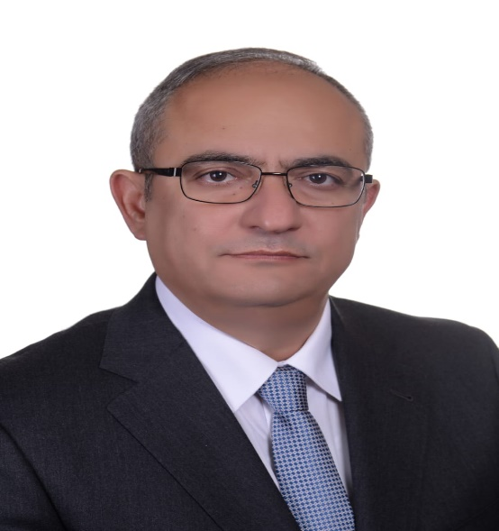
- Last Name Al Majali
- First Name Rami
- D.O.B 13 th Dec 1967
- Nationality Jordanian
- Status Married

- Address P.O.Box 460
Amman 11947
Jordan
-Tel. Mobile 00 962 799035184
- E-Mail rami.majali@mutah.edu.jo
rami.almajali@yahoo.com

Certificates & Licenses :

- Bachleor of Medicine M.B.B.S.Jordan University June 1991.
- Jordanian Board of Pediatrics, Jordanian Medical Council March 1997.
- ECFMG Certificate (USA) December 1998.
- MRCPCH ( U K, London ) October 2000 .
- Certificate of Registration, General Medical Council, UK.
- Jordanian Board of pediatric hematology oncology from the Jordanian Medical Council.
- Master degree in Conflict Resolution and Managment from Faculty of International Studies, Unversity of Jordan. June 2019
- Certificate of Certified Physician Exceutive (CPE) from the American Association for Physician leadership (AAPL), march 2020

Postgraduate Clinical Training :

- July 1991 - June 1992 : Rotating internship at Al-Basher Hospital Ministry of Health Amman,Jordan .
- July 1992 - January 1993 : General Medicine Practice in medical units of Jordanian army .
- January 1993 - January 1997 : pediatric resident , King Hussein Medical Center, Royal Medical Services (RMS) of Jordan , Amman , Jordan .
- February 1997 – Oct. 1999 : Assistant specialist in pediatrics, at King Hussein Medical Center & Senior specialist at Princess Haya Hospital (RMS) , Aqaba.
- October 1999 – October 2000 : Pediatric SHO in Singleton Hospital, Swansea, Wales, UK.
- October 2000 – January 2003 : General Pediatric Specialist at RMS.
- January 2003 – February 2005 : Pediatric Hematology / Oncology fellow in King Hussein Medical Center at the RMS of Jordan.
- March 2005 – August 2005 : Newcastle General Hospital, Bone Marrow Transplant Unit, specialist registrar UK.
- Septemper 2005 – Septemper 2006 : Royal Vectoria Infirmary Hospital, Newcastle, pediatric and adolecent oncology, specialist registrar UK.
- Septemper 2006 – Feb.2010 : King Hussein Medical center, pediatric hematology oncology team.
- May 15th 2011-June 15th 2011: St. Jude Children's Research Hospital, clinical attachment and observation in leukemia, solid tumours, BMT and brain tumours services USA.
- Feb.2010- Nov.2016:Queen Rania Alabdallah Children Hospital QRCH, Pediatric hematology oncology consultant.
- Nov.2015 – August 2019: Head of pediatric hematology oncology and BMT service at QRCH.
- Nov.2014 – December 2020 : Clinical staff member for medical students of Faculty of Medicine, University of Jordan.
- Ocotober 2018 – December 2020 : Accredeite pediatric hematology oncology consultant for training for the arab board of health specializatins fellowship program.
- August 2019- December 2020: Head of Militery Cancer Center of the Royal medical Services (RMS) of Jordanian Armed Forces, Amman Jordan.
- July 2021 – Current : Lecturer ( assistant professor level ) at Muta University, Facult of medicine, pediatric department.

Positions Held :

- Head of the Militery Cancer Center of the Royal medical Services (RMS), Reteired Brigadier General.
- Head of pediatric hematology oncology and BMT service at RMS.
- Member of the scientific committee of the Jordanian pediatric hematology oncology subspeciality of the Jordanian Medical Council since 2015.
- Accredited trainer for the pediatric hematology oncology for training for the arab board of health specializatins
- Clinical staff member for medical students of Faculty of Medicine, University of Jordan since 2014.
- Member of the drug studies committee of the Jordanian Drug and Food Association (JFDA)since October 2018.
- Lecturer ( assistant professor level ) at Muta University, Facult of medicine, pediatric department currently.

Memberships :

- Jordanian Medical Association.
- Jordanian Society of Pediatrics.
- Jordanian Society Of Pediatric Oncology.
- MRCPCH (London).
- UKCCSG(UK).
- American Association for Physician Leadership AAPL.

